Privacy Notice

Height and weight checks for children in Reception and Year 6

Each year in England, school children in Reception and Year 6 have their height and weight checked at school as part of the National Child Measurement Programme (NCMP). Height and weight measurements are used to calculate weight status. We collect this information because it is used nationally to monitor trends in child obesity and overweight, and locally to inform the planning and delivery of health improvement services for children. Your child’s class will take part in this year’s programme.

The checks are carried out by trained school nurses or trained health care providers. Children are measured fully clothed, except for their coats and shoes, in a private space away from other pupils. The programme will be delivered in a COVID-safe way, in line with the school and local authority’s safety control measures and national guidance for schools and healthcare.

Maintaining the well-being of children in the NCMP
The wellbeing of children and families is very important. Measurements are conducted in a sensitive way, in private and away from other children. Individual results are not shared with your child or their school. Height and weight information is shared only with you in the parent or carer feedback letter. It is your choice if you use the height and weight information provided in the parent or carer feedback letter to calculate your child’s Body Mass Index. It is your choice if you share the information with your child. If you are concerned about your child’s growth, weight, body image or eating patterns, seek further support from a School Nurse or General Practitioner.

The emotional impact of the NCMP has been researched and studies show that body image, self-esteem, weight-related teasing and restrictive eating behaviours do not change as a result of being measured or receiving feedback.

The information we collect from schools and what it is used for is listed below:
- your child’s date of measurement, sex and date of birth are used to calculate your child’s weight category
- your child’s name, date of birth and NHS Number are used to link your child’s measurements in Reception and Year 6. Other data sets held by NHS Digital and Department of Health and Social Care may also be linked as this would let us add information from health and education records, where lawful to do so, to understand how and why the weight of children is changing, and how this affects children’s health and education and how we can improve the care children receive. This includes your child’s health data relating to;
  - their birth, hospital care (including time in hospital and out-patient appointments and diagnosis of medical conditions)
  - mental health
  - social care
  - primary care - includes all healthcare outside of hospital such as GP and dental appointments,
  - public health - including data relating to preventing ill health such as immunisation records
  - records for when and the reason why people pass away
  - medical conditions such as cancer, diabetes
  - health, lifestyle and wellbeing surveys that your child has participated in
- your child’s ethnicity and address are used to help understand some of the reasons for the difference and changes in child weight across England
- your address is required to send you your child’s feedback letter. This will include your child’s height and weight measurements together with a link to the NHS BMI calculator and information about healthy eating, being active and related activities available in your area.
- your email address and telephone number are required as we may contact you by email or telephone to discuss your child’s feedback/ send you your child’s feedback letter by email/ offer you further support following your child’s height and weight measurement.
- If your child’s measurements are show that they are underweight, very overweight or extremely short, we may also send a copy of the measurements to your child’s GP asking them to make an appointment with you so they can investigate any underlying medical conditions.

All of the data collected is also used for improving health, care and services through research and planning.

All this information is treated confidentially and held securely by us. No individual measurements will be given to school staff or other children.

How the data is used
The information collected from all schools in the area will be gathered together and held securely by Cornwall Council and you can contact them on 01872 326424 or email them at dataprotection@cornwall.gov.uk.

All the information collected about your child will be sent by us to NHS Digital. NHS Digital is responsible for collecting data and information about health and care so that this can be used to monitor and improve the care provided to people across England.

The information collected about your child will also be shared by NHS Digital with the Office for Health Improvement and Disparities (OHID) which is part of the Department of Health and Social Care, but in a de-personalised form only. This means OHID will not be able to identify your child. OHID focusses on improving the nation’s health so that everyone can expect to live more life in good health, and on levelling up health disparities to break the link between background and prospects for a healthy life.

Both NHS Digital and the Office for Health Improvement and Disparities (DHSC) will use the information from the NCMP to better understand numbers and trends in child weight and body mass index (BMI). This helps with the planning of services to support healthy lifestyles in your area. No information will ever be published by NHS Digital or the Office for Health Improvement and Disparities (DHSC) that identifies your child.

De-personalised information from the NCMP may also be shared by NHS Digital with other organisations, such as universities. This is to help improve health, care and services through research and planning. This information cannot be used to identify your child, and NHS Digital only ever shares information for research with the approval of an independent group of experts.

Withdrawing your child from the NCMP
If you are happy for your child to be measured, you do not need to do anything.
If you do not want your child’s height and weight to be checked, or your child has a medical condition that affects their height or weight please let us know my emailing ncmp@cornwall.gov.uk

Children will not be made to take part on the day if they do not want to.

Further information
Further information about the NCMP can be found at https://www.nhs.uk/live-well/healthy-weight/national-child-measurement-programme

Information and fun ideas to help your family stay healthy can be found at
https://www.nhs.uk/healthier-families

Information about how NHS Digital and the Office for Health Improvement and Disparities collect and use information can be found at https://digital.nhs.uk/about-nhs-digital/our-work/keeping-patient-data-safe/how-we-look-after-your-health-and-care-information and https://www.gov.uk/government/organisations/department-of-health-and-social-care/about/personal-information-charter

Information about the organisations NHS Digital has shared information from the NCMP can be found at https://digital.nhs.uk/services/national-child-measurement-programme

How your child’s data is collected and processed as part of the NCMP
Local authorities have a legal duty to collect the NCMP data. They do this by following guidance from the Office for Health Improvement and Disparities part of the Department of Health and Social Care. Local authorities are responsible for making decisions on how the data is collected and for making sure it is protected. Local NCMP service providers are contracted to carry this out; this might be through the school nursing team working in schools or a local healthcare provider. The team collecting the data enter it into the NCMP IT system, which is provided by NHS Digital. Your local authority is responsible for sending the data to NHS Digital. NHS Digital and the Office for Health Improvement and Disparities are jointly responsible for the data held at a national level. Your local authority is responsible for the data held locally.

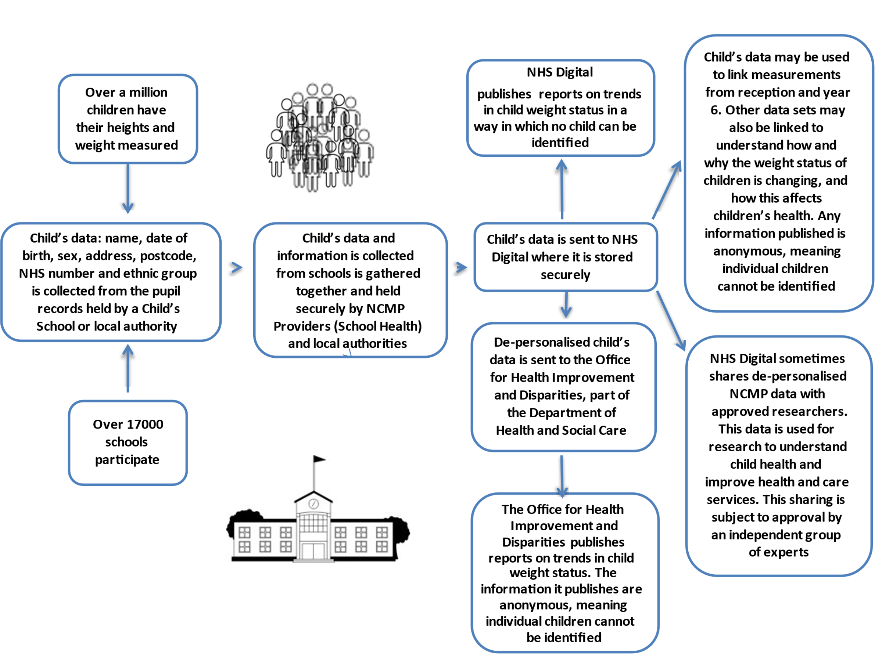

Royal Cornwall Hospitals Trust (RCHT)

Vision and hearing screening

The RCHT will be processing your child’s data in order to provide visual and /or hearing services. Your child’s information will only be accessed by those staff that are involved in the provision of these services and will not be shared with others unless there is a legal reason to do so.

If you wish to know more about your rights with regard to Data Protection, please visit our website on https://www.royalcornwall.nhs.uk/our-care-promise/

If you wish to discuss this, please contact the Trust Data Protection Officer:
email: rcht-tr.infogov@nhs.net or tel: 01872 255014.

